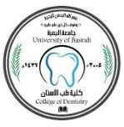
Endodontics
Lec.8 د.فرح عبد الرزاق
Obturation
Objective of obturation (filling the root canal):
The objective is to create a fluid-tight seal along the length of the root canal system, from the coronal opening to apical termination (particularly at the apical foramen), to prevent an ingress of tissue fluid and bacteria and subsequently egress of irritants.
Ingress inward movement of tissue fluid.
Egress outward movement of irritants.
Fluid moves due to osmotic pressure to the empty space, in case of root canal, if it’s left empty without filling, the tissue fluid might stay for a while and then fill this empty canal. Due to no circulation and no lymphatic system, it undergoes degeneration and destruction then foreign body leaks again to the periapical area leading to inflammation, or bacteria may find a way in this space so live and proliferate and produce enzymatic toxins, then seep again to the periapical area and cause infection of the periapical area.
Criteria for filling:
1. Prepare the root canal in a manner that ensures the optimum access to apical area.
2. The tooth must be asymptomatic (no pain and tenderness).
3. The canal must be dry.
4. No sinus tract
5. No foul odor
6. Negative culture. This is controversial, some say that they need –ve culture, the other say no significance from it.
Materials used to obturate the root canal
1) Gutta- Percha
The most commonly used semi sold root canal filling material. It’s either standardized cone or non-standardized.
a) Standardized Cone
It is designed to have the same size and tapering of the corresponding intra canal instrument as a master cone.
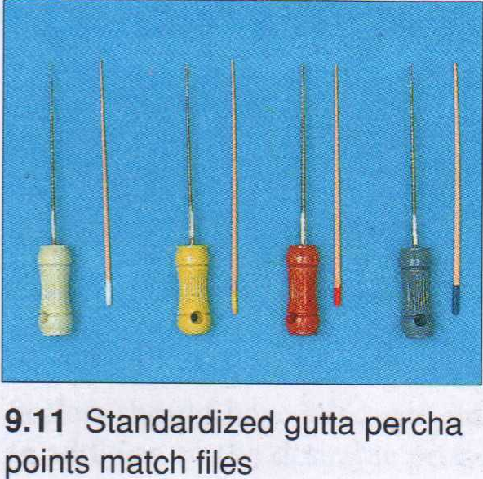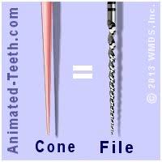

b) Non-standardized Cone
This cone has greater tapering in which fine tip and heavy body, it’s used with master cone to aid it in obturation.
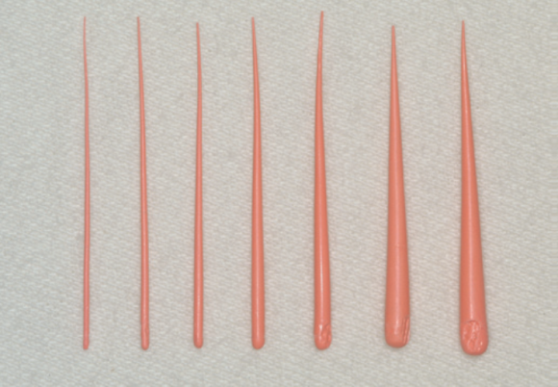
2) Silver Points
These points are made from silver. They have the advantage of being rigid; therefore they are used in very narrow and severely curved canals. The main disadvantages are that silver cones are round in cross section, therefore, they can not be used in oval cross sectioned canals, and silver cones may produce corrosion products which will be harmful to the periapical region.
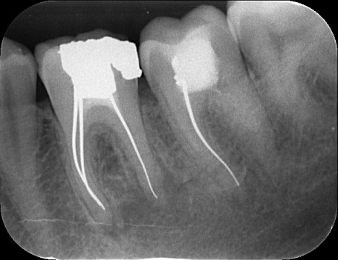
3) Sealer
It is a paste mostly made of radiopaque material capable of producing a seal by filling irregularities between the gutta percha & the dentine walls. The sealer acts as lubricant facilitating placement of the gutta percha cone. It is supplied in two pastes or liquid and powder which are mixed to produce a thick, creamy consistency. In general, the four major types of sealers are zinc oxide–eugenol based, resin based (epoxy resin or methacrylate resin) sealers, glass ionomer, and those containing calcium hydroxide. Regardless of the sealer selected, all exhibit toxicity until they have set. For this reason, extrusion of sealers into the periradicular tissues should be avoided.

4) Absorbent Points
Points that are made of absorbent paper which are in the same standardized sizes as the root canal instruments. They are used to dry to the root canal.

Technique in root canal obturation
Lateral Condensation Technique with gutta percha.
This is the most commonly used obturating technique for most of the root canal system configurations. Before obturation of the root canal, we should verify the completion of root preparation and ensure a dry and symptom less tooth, so we use the absorbent point to dry the canal after irrigation.
Procedure of Master cone selection (the cone that occupies most of the root canal parts).
1- The selected master cone, should have the same size of the M.A.F. & it should have the same length of the full working length.
2- The master cone should need some force to be seated inside the canal & some force is required to dislodge the master cone from the canal. This is called Tug back. This resistance of removal of the master cone enhances the sealing ability at the apical area of the root canal
3- If the master cone goes to the full working length but it's loose inside the canal, we take a
larger gutta percha cone or we remove l mm from the apical end of the master cone to increase the width of the master cone.
4- Verify the master cone position with a radiograph to ensure the optimum fitness.
5- Mix the sealer & coat the wall by picking up sealer on MAF & spin it counter-clockwise. Once the M.A.F. is rotated, there will painting of the walls with the sealer.
6- Dip the tip of master cone in the sealer & seat it in the root canal.
7- By the use of the spreader; the master cone is pushed laterally & apically providing room for auxiliary gutta percha point. The spreader should rotate 180° (to the right & left) until it becomes loose & pushed out-side.
8- The spreader should penetrate the apical 1/3 (a rubber stopper should be placed to mark the length of penetration 2-3 mm from the tip of the master cone).
9- Place an auxiliary cone (which is smaller than the master cone) after its tip is dipped in the sealer.
10- Repeat the process by more gutta percha points and more spreading until the entire canal is filled when the spreader can't be placed beyond the cervical line of the root canal:
11- Take a radiograph to check the obturation mass.
l2- A hot instrument is used to cut the excess gutta percha to just below the cervical line. The instrument used can be either an excavator or ash no. 6 and should be very hot to cut in one motion. If the instrument is not hot enough then the master cone might be dislodged.
13- A plugger is used for vertical condensation to assure tightness of the condensation.
14- All the sealer & gutta percha should be removed from the pulp chamber by a round bur.
15- The cement base material and a coronal restoration are placed in the tooth.
.

